**Ideation Phase**

**Define the Problem Statements**

|  |  |
| --- | --- |
| Date | 26 June 2025 |
| Team ID | LTVIP2025TMID34134 |
| Project Name | Pollen's Profiling: Automated Classification of Pollen Grains |
| Maximum Marks | 2 Marks |

**Customer Problem Statement Template:**

**As a researcher/doctor/agronomist,** I need a faster and more reliable way to identify and classify pollen grains because manually analyzing them under a microscope is time-consuming, error-prone, and requires expert knowledge. This slows down my ability to make timely decisions—whether it's diagnosing allergies, monitoring biodiversity, or managing crop pollination. I often struggle with inconsistent results and lack of access to automated tools, which makes my work harder and less accurate. If I had a simple, AI-powered system that could automate this process, I could focus more on insights and action rather than tedious data analysis. Graphical user interface, text, application, email

**Example:** 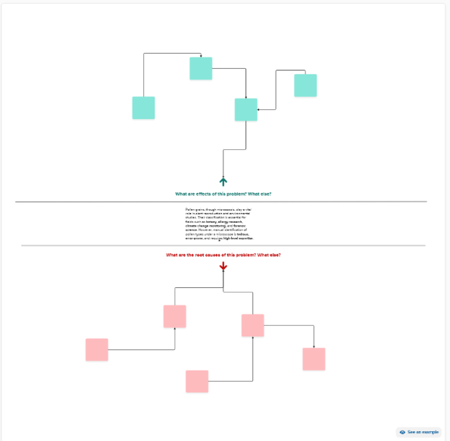

|  |  |  |  |  |  |
| --- | --- | --- | --- | --- | --- |
| **Problem Statement (PS)** | **I am (Customer)** | **I’m trying to** | **But** | **Because** | **Which makes me feel** |
| PS-1 | Identification | Find | image | Scanning | Prediction |
| PS-2 | recognition | Verify | Data | Scanning | Prediction |